TYBSc CS 2020-2021 USCS607:Wireless Sensor Network

RollNo: 18043 Date: 03/02/2021

**Practical No.:4**

**Aim: Create simple Adhoc network.**

**Simulator used : Omnet++**

● Simulator can be downloaded from link: **https://omnetpp.org/download/old**

● After installing Omnet++, we need to install inet framework which is specially designed for wireless simulation. You can download inet framework from link : [**https://inet.omnetpp.org/Download.html**](https://inet.omnetpp.org/Download.html)

● After downloading there are certain steps to be followed to include this framework in omnet++ as follows:

● **Download the INET sources.**

**● Unpack it into the directory of your choice**

**● Recommeded version is inet 2.1**

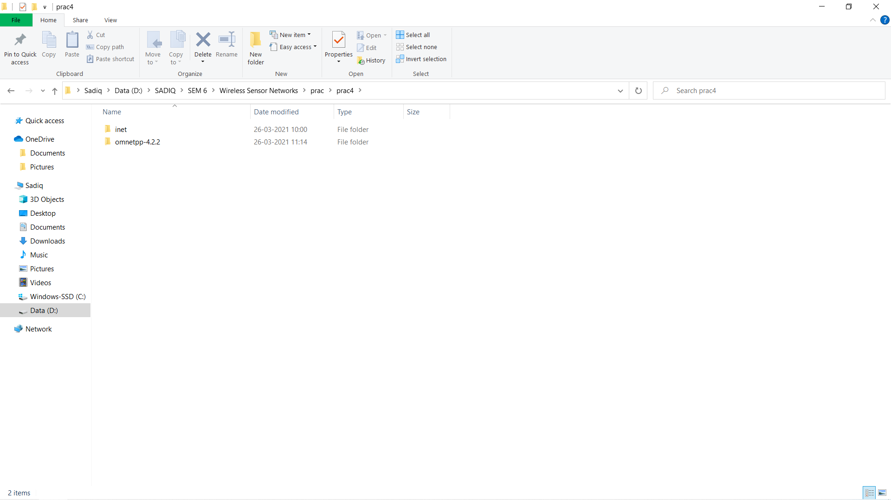

* **Now install omnet++ as shown below:**

**Open MINGW32 in extracted omnet++ folder and type :**

1. **. setenv**
2. **./configure**
3. **make**

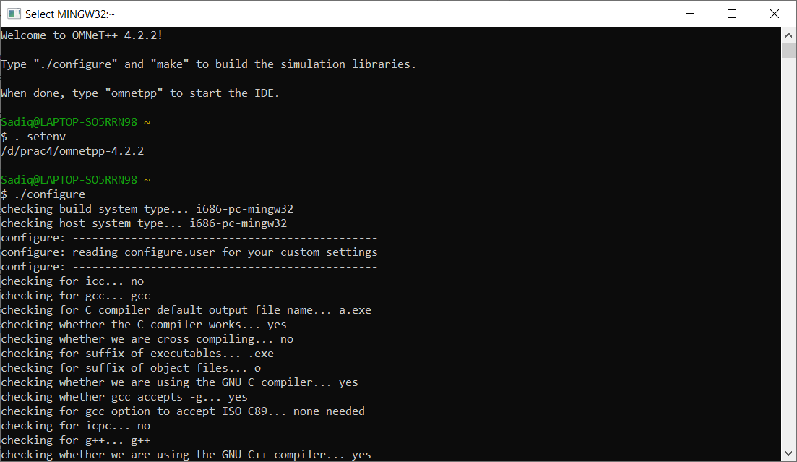

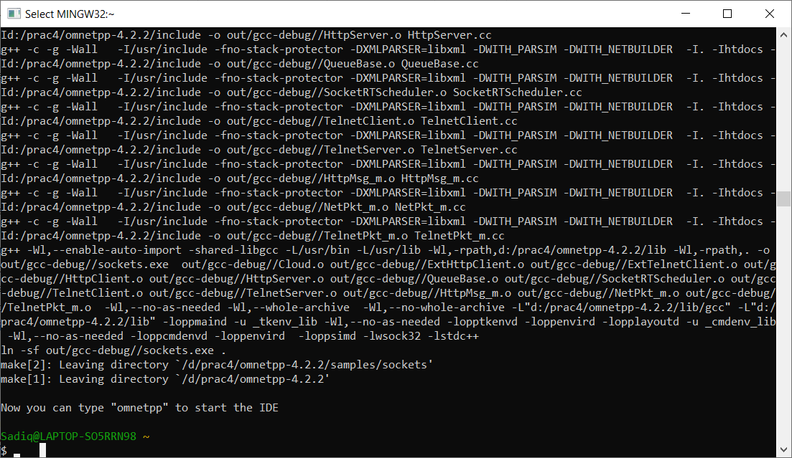

**● Start the Omnet++ IDE, and import the project via File -> Import -> Existing Projects to the Workspace. A project named inet should appear.**

**● Build with Project -> Build, or hit ctrl+b**

**● Now you should be able to launch example simulations.**

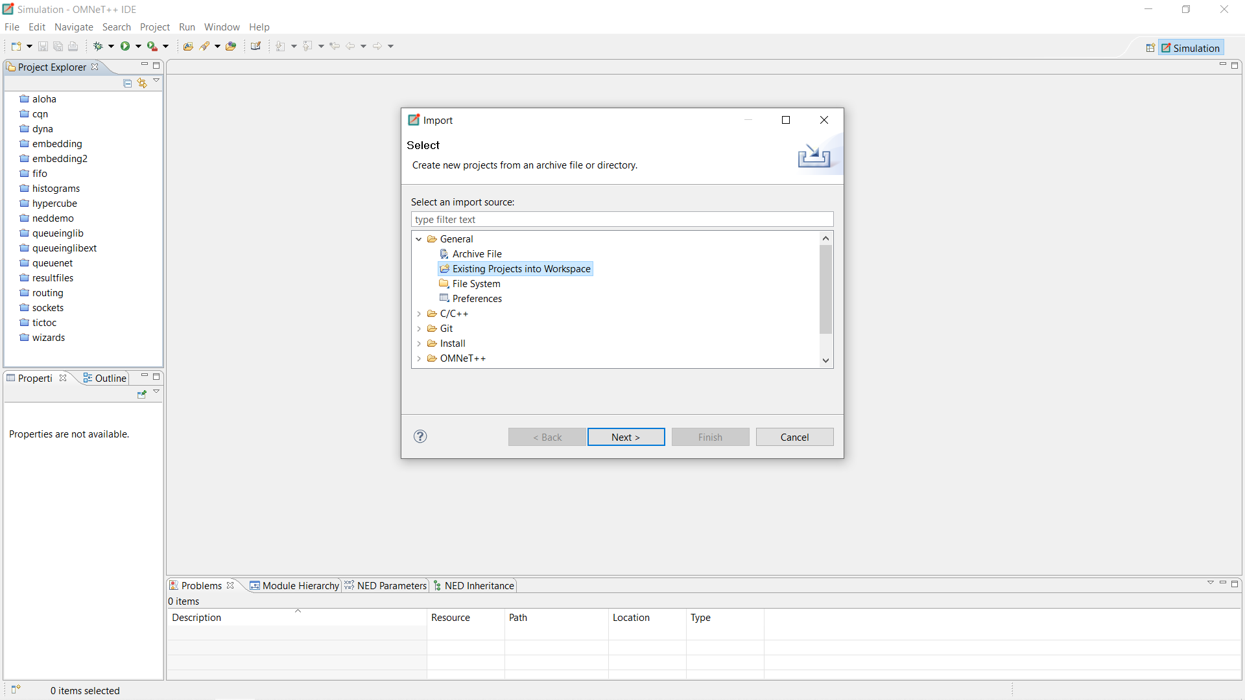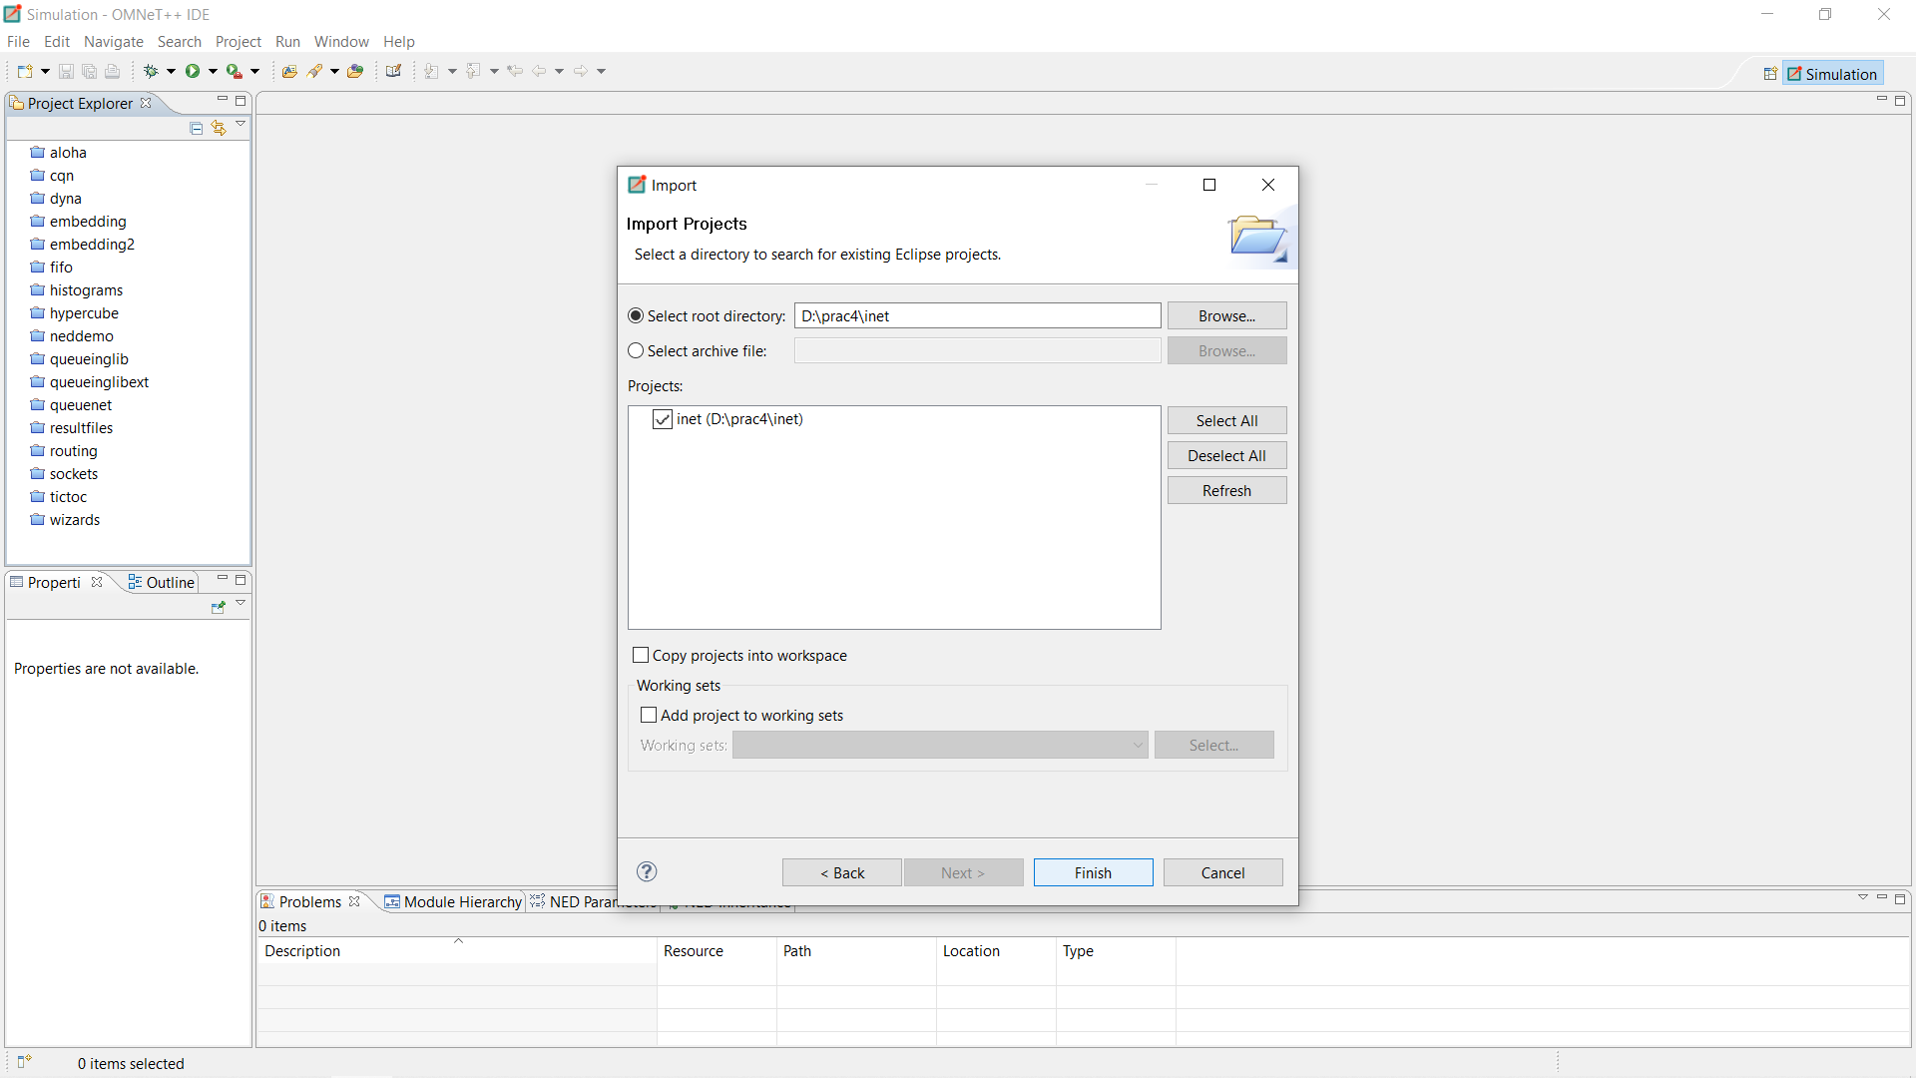

**Steps for practical:**

**● Then open inet/examples/**

**● Right click on adhoc -create new folder as SimpleAdhoc.**

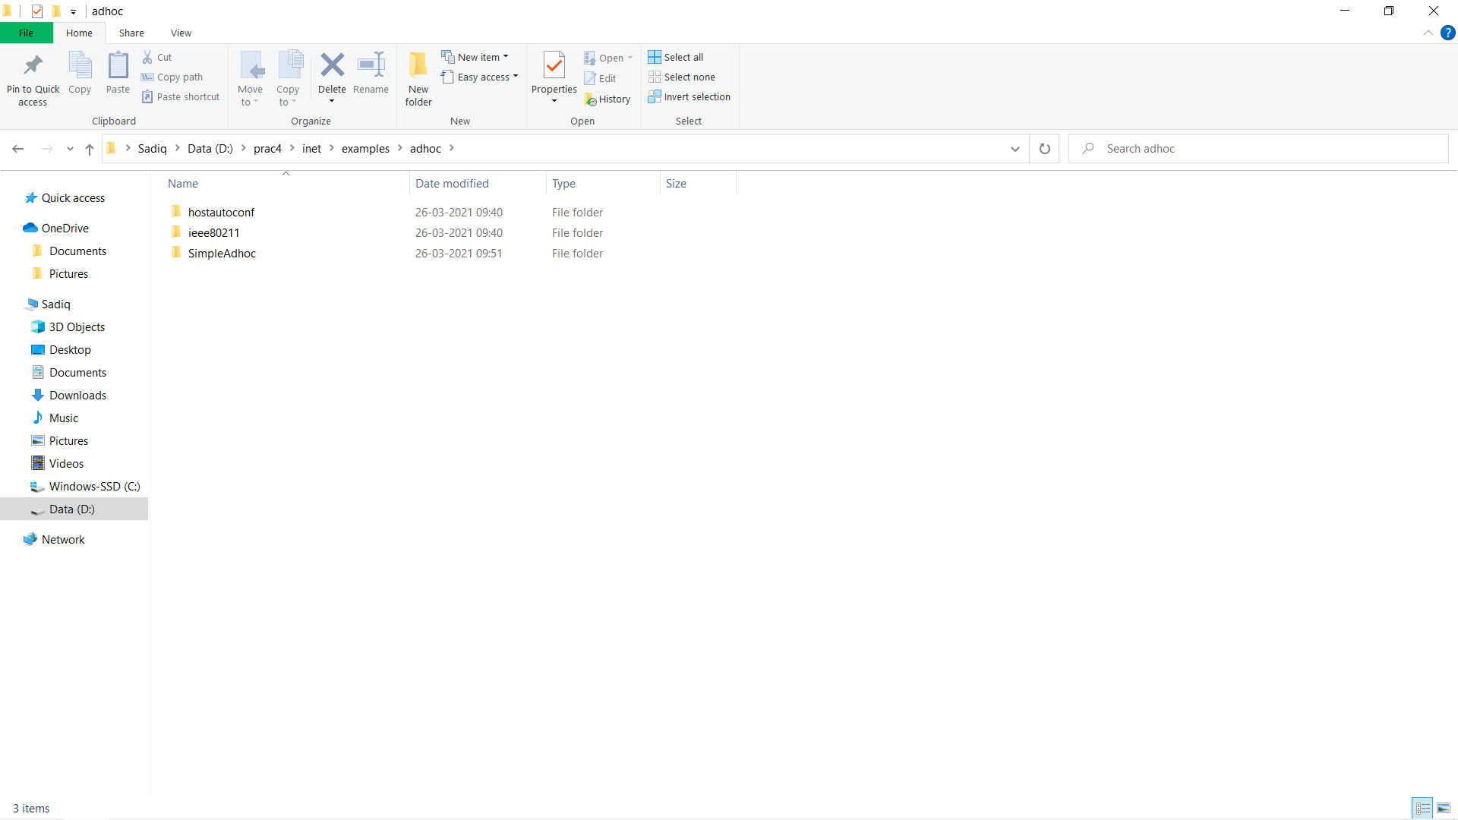

**● Right click on your newly created folder and select NED file. Give name as sadiq**

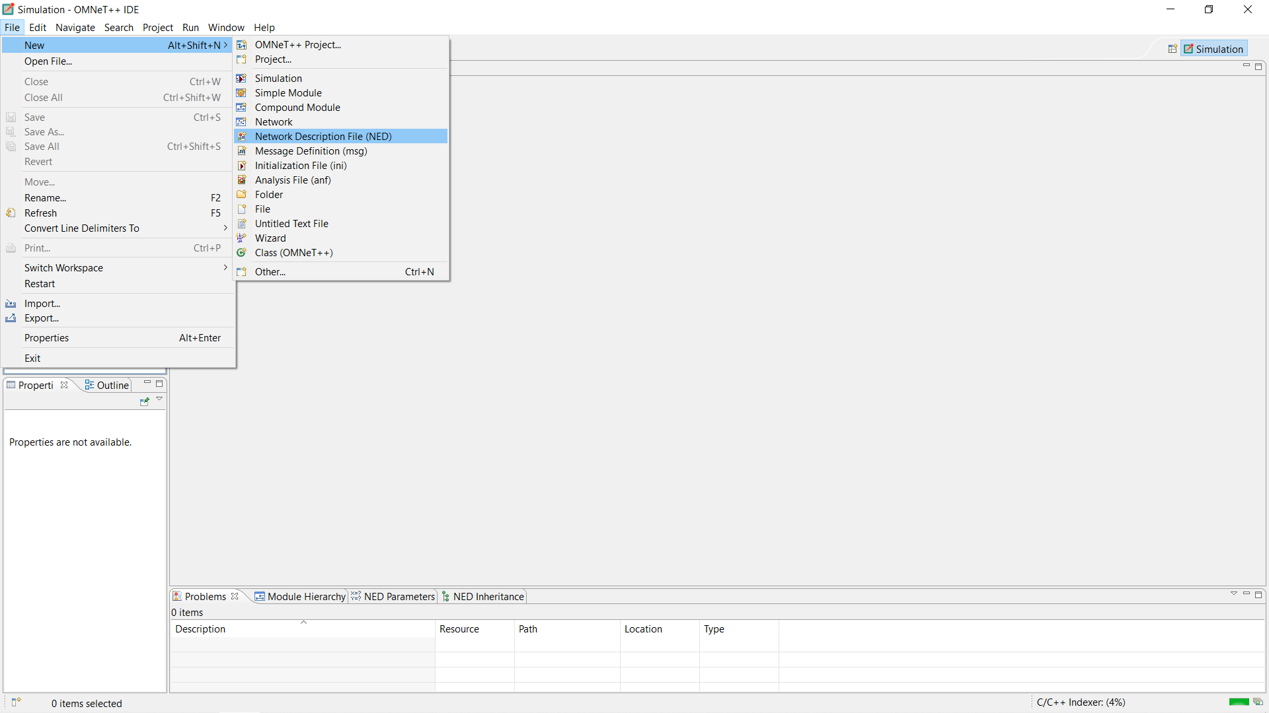

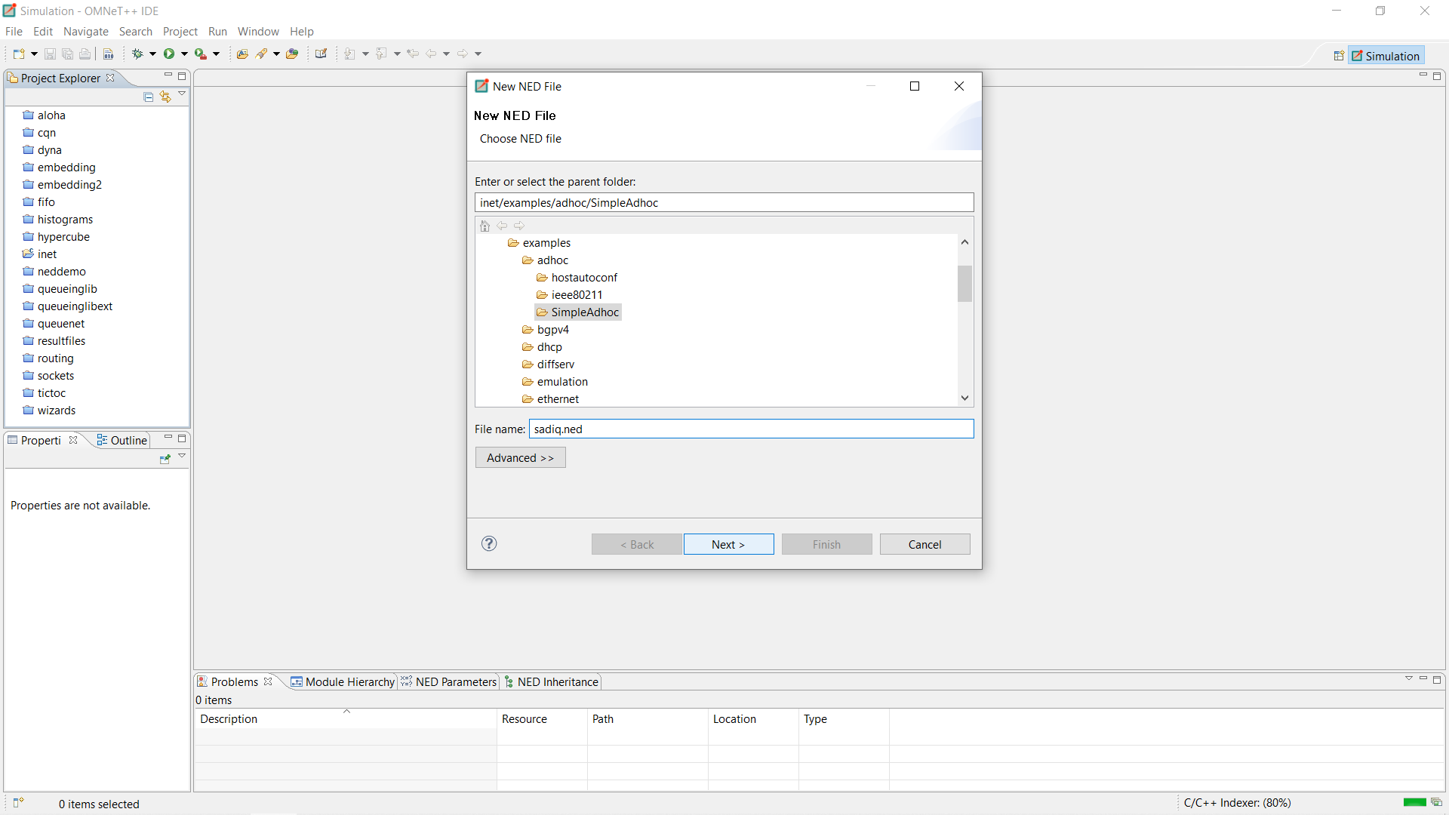

**●Click on new manages mobility wireless network wizard.**

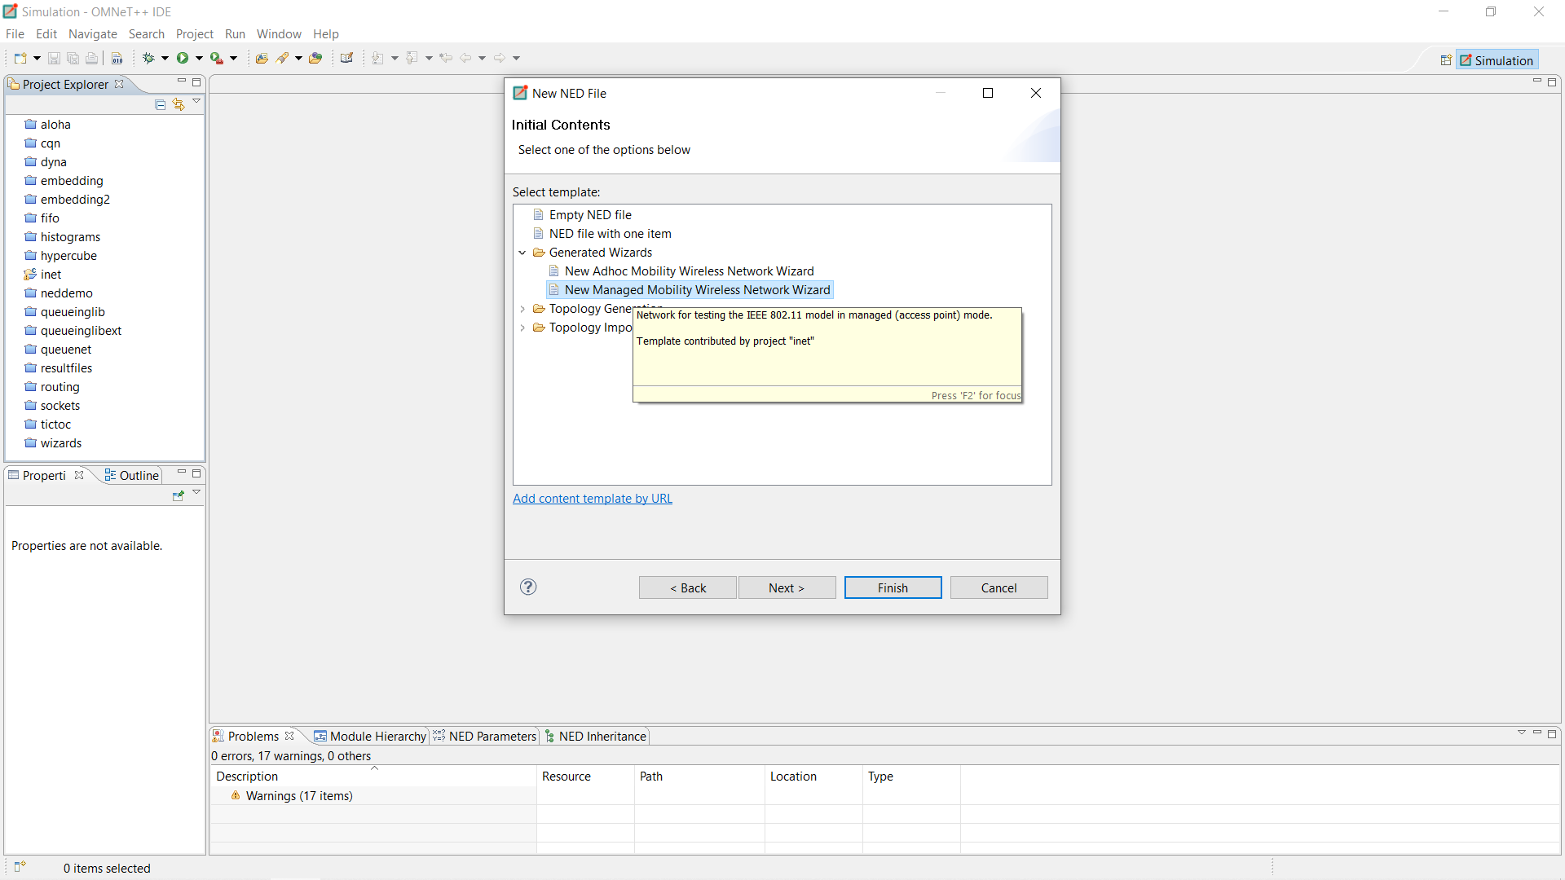

**●Then configure as follows:**

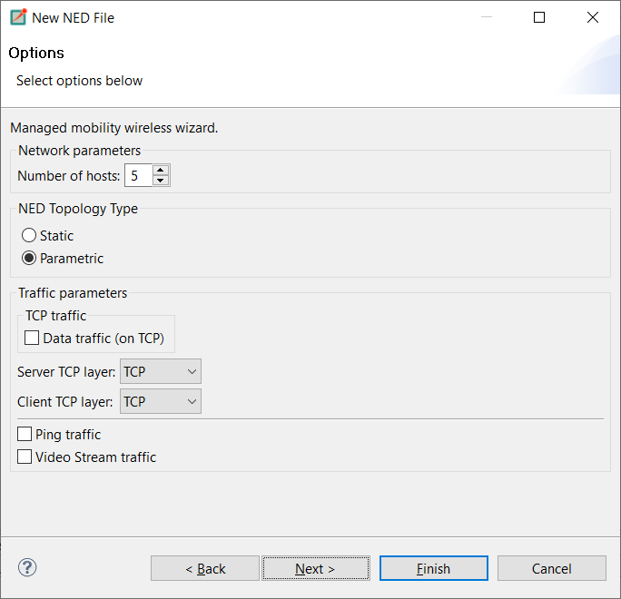

**●Then click on finish.**

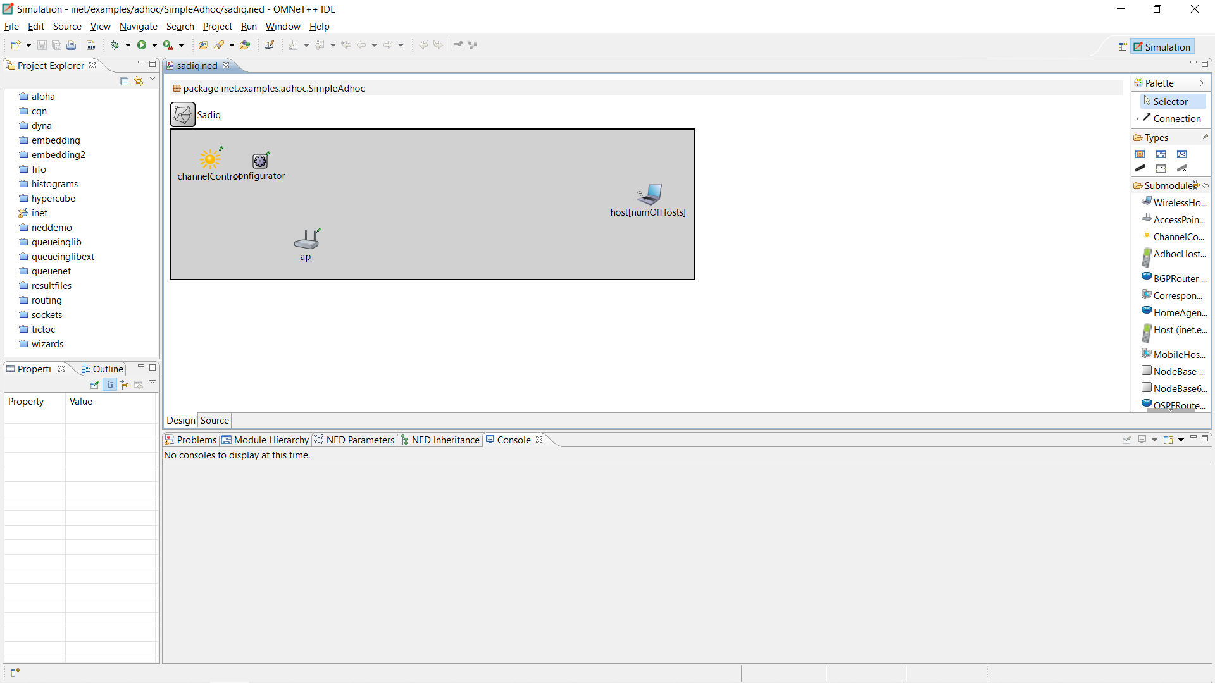

**● Below is the code that will be available in source part of sadiq.ned once configured.**

**package** inet.examples.adhoc.SimpleAdhoc;

*// numOfHosts: 5*

**import** inet.networklayer.autorouting.ipv4.IPv4NetworkConfigurator;

**import** inet.nodes.inet.WirelessHost;

**import** inet.nodes.wireless.AccessPoint;

**import** inet.world.radio.ChannelControl;

**network** Net

{

**parameters**:

**int** numOfHosts;

**submodules**:

host[numOfHosts]: WirelessHost

{

**@display**("r=,,#707070");

}

ap: AccessPoint

{

**@display**("p=213,174;r=,,#707070");

}

channelControl: ChannelControl

{

numChannels = 2;

**@display**("p=61,46");

}

configurator: IPv4NetworkConfigurator

{

**@display**("p=140,50");

}

}

**● On design part you will find components appearing according to the code as the above snapshot.**

**Same as do this in omnetpp.ini file :**

**Source code for omnetpp.ini:**

[General]

network = Net1

*.numOfHosts = 5

*#debug-on-errors = true*

tkenv-plugin-path = ../../../etc/plugins

**.constraintAreaMinX = 0m

**.constraintAreaMinY = 0m

**.constraintAreaMinZ = 0m

**.constraintAreaMaxX = 600m

**.constraintAreaMaxY = 400m

**.constraintAreaMaxZ = 0m

**.debug = **true**

**.coreDebug = **false**

**.host*.**.channelNumber = 0

*# channel physical parameters*

*.channelControl.carrierFrequency = 2.4GHz

*.channelControl.pMax = 2.0mW

*.channelControl.sat = -110dBm

*.channelControl.alpha = 2

*# mobility*

**.host*.mobilityType = "MassMobility"

**.host*.mobility.initFromDisplayString = **false**

**.host*.mobility.changeInterval = truncnormal(2s, 0.5s)

**.host*.mobility.changeAngleBy = normal(0deg, 30deg)

**.host*.mobility.speed = truncnormal(20mps, 8mps)

**.host*.mobility.updateInterval = 100ms

*# ping app (host[0] pinged by others)*

*.host[0].numPingApps = 0

*.host[*].numPingApps = 2

*.host[*].pingApp[*].destAddr = "host[0]"

**.pingApp[0].startTime = uniform(1s,5s)

**.pingApp[1].startTime = 5s+uniform(1s,5s)

**.pingApp[*].printPing = **true**

*# nic settings*

**.wlan[*].bitrate = 2Mbps

**.wlan[*].mgmt.frameCapacity = 10

**.wlan[*].mac.address = "auto"

**.wlan[*].mac.maxQueueSize = 14

**.wlan[*].mac.rtsThresholdBytes = 3000B

**.wlan[*].mac.retryLimit = 7

**.wlan[*].mac.cwMinData = 7

**.wlan[*].radio.transmitterPower = 2mW

**.wlan[*].radio.thermalNoise = -110dBm

**.wlan[*].radio.sensitivity = -85dBm

**.wlan[*].radio.pathLossAlpha = 2

**.wlan[*].radio.snirThreshold = 4dB

[Config Ping1]

description = "host1 pinging host0"

[Config Ping2] *# interactive*

description = "n hosts"

*# leave numHosts undefined here*

**.mobility.constraintAreaMinZ = 0m

**.mobility.constraintAreaMaxZ = 0m

**.mobility.constraintAreaMinX = 0m

**.mobility.constraintAreaMinY = 0m

**.mobility.constraintAreaMaxX = 600m

**.mobility.constraintAreaMaxY = 400m

**.debug = **false**

**.coreDebug = **false**

**.channelNumber = 0

*# channel physical parameters*

*.channelControl.carrierFrequency = 2.4GHz

*.channelControl.pMax = 20.0mW

*.channelControl.sat = -110dBm

*.channelControl.alpha = 2

*# mobility*

**.host[*].mobilityType = "MassMobility"

**.host[*].mobility.changeInterval = truncnormal(2s, 0.5s)

**.host[*].mobility.changeAngleBy = normal(0deg, 30deg)

**.host[*].mobility.speed = truncnormal(20mps, 8mps)

**.host[*].mobility.updateInterval = 100ms

*# nic settings*

**.bitrate = 2Mbps

**.mac.address = "auto"

**.mac.maxQueueSize = 14

**.mac.rtsThresholdBytes = 3000B

**.wlan[*].mac.retryLimit = 7

**.wlan[*].mac.cwMinData = 7

**.wlan[*].mac.cwMinMulticast = 31

**.radio.transmitterPower = 20.0mW

**.radio.carrierFrequency = 2.4GHz

**.radio.thermalNoise = -110dBm

**.radio.sensitivity = -85dBm

**.radio.pathLossAlpha = 2

**.radio.snirThreshold = 4dB

*# relay unit configuration*

**.relayUnitType = "MACRelayUnitNP"

**.relayUnit.addressTableSize = 100

**.relayUnit.agingTime = 120s

**.relayUnit.bufferSize = 1MiB

**.relayUnit.highWatermark = 512KiB

**.relayUnit.pauseUnits = 300 *# pause for 300*512 bit (19200 byte) time*

**.relayUnit.addressTableFile = ""

**.relayUnit.numCPUs = 2

**.relayUnit.processingTime = 2us

**EXECUTION:**

**Now try to execute by right click on ned file Run as-1-Omnet++ simulation.**

